Evaluating PFOS and PFOA Standards: Health Risks, Population Exposure, and Regulatory Implications

Per- and polyfluoroalkyl substances (PFAS), including perfluorooctane sulfonate (PFOS) and perfluorooctanoic acid (PFOA), are persistent environmental pollutants with significant health implications. This study uses a novel Relative Health Indicator (RHI) metric to assess potential health risk reductions under different regulatory standards by normalizing contaminant risk to a single scale. This metric enables us to quantify a “meaningful opportunity” for a potential regulation and compare across previously determined regulatory contaminant values to help establish a minimum threshold for identifying significant regulatory opportunities. Using this metric, we are also able to compare the U.S. Environmental Protection Agency's (USEPA) 2024 enforceable maximum contaminant levels (MCLs) of 0.02 ng/L for PFOS and 0.004 ng/L for PFOA with thresholds from governmental and state agencies. When the USEPA proposed a health advisory level of 70 ng/L in 2016, the population considered exposed under this metric was relatively low, 1.44% for PFOA and 0.18% for PFOS. However, with the updated MCL set at significantly lower values of 0.02 ng/L for PFOS and 0.004 ng/L for PFOA, the number of people classified as exposed has substantially increased to 19.91% for PFOS and 17.49% for PFOA. States with high PFAS occurrences, commonly found in groundwater systems regardless of system size, such as Connecticut, Hawaii, Illinois, New York, and California, have standards aligned with the USEPA’s stringent thresholds, leading to higher reported exposures. In contrast, states using higher threshold limits report fewer exposures. California’s RHI dropped significantly from 2019 to 2024, despite maintaining the same threshold and percentage population exposed. This reduction is attributed to a change in the cancer slope factor, which shifted from 143 for PFOA and 45.5 for PFOS in 2019 to an assumed value of 0.07 for both, aligning with the current EPA standards.. One key challenge is that current detection methods often exceed these lower MCLs, making it difficult to confirm compliance as concentrations below current detection limits may still exceed MCL. Findings from this risk assessment underscore the trade-off between public health protection and regulatory burden, highlighting the need for improved detection technologies and balanced policy approaches to ensure public safety.

Keyword: Health Risk, MCL, PFOA, PFOS, RHI metric, Risk Assessment

Method 1: Exclude NAs – Raw data for PFOS/PFOA: 143629 obs. = 5712 report + 143629 NAs. Data skewed right, mean = 0.0194 ug/L.
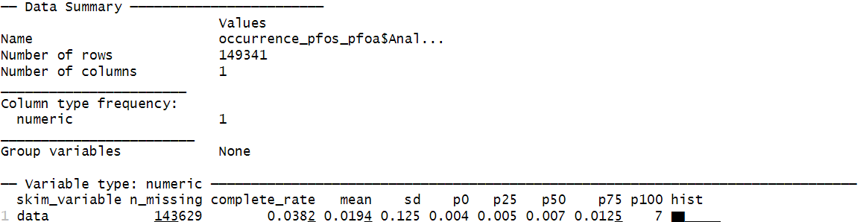

Table 1. Current (2024) USEPA approved methods to detect PFOS and PFOA used in UCMR3/UCMR4.
MethodID | MRL | Units | MRL | Units | MRL | Units
EPA 533 | 4 | ng/L or ppt | 0.004 | µg/L or ppb | 0.000004 | mg/L or ppm
EPA 537 | 20 | ng/L or ppt | 0.02 | µg/L or ppb | 0.00002 | mg/L or ppm
EPA 537 | 40 | ng/L or ppt | 0.04 | µg/L or ppb | 0.00004 | mg/L or ppm

(a)
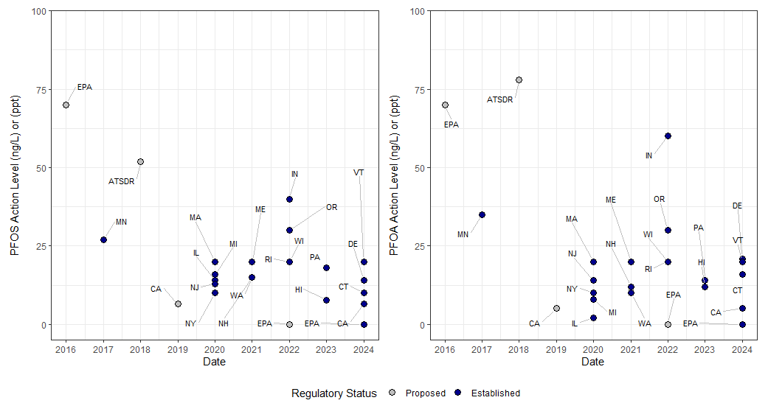
(b)

Figure 1.Proposed and established regulatory thresholds for (a) PFOA and (b) PFOS by governmental and state agencies. In 2016 USEPA proposed 70 ng/L as health advisory levels for PFOS and PFOA. In 2024, USEPA published the final enforceable MCL, 0.02 ng/L for PFOS and 0.004 ng/L for PFOA.
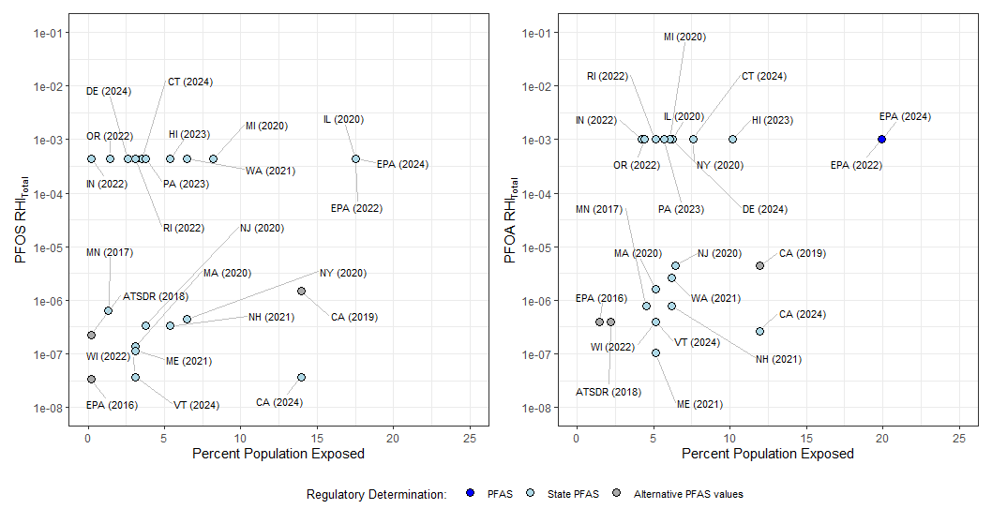
Figure 2. Total RHI and percent population exposed to threshold concentrations proposed (excluding NAs).

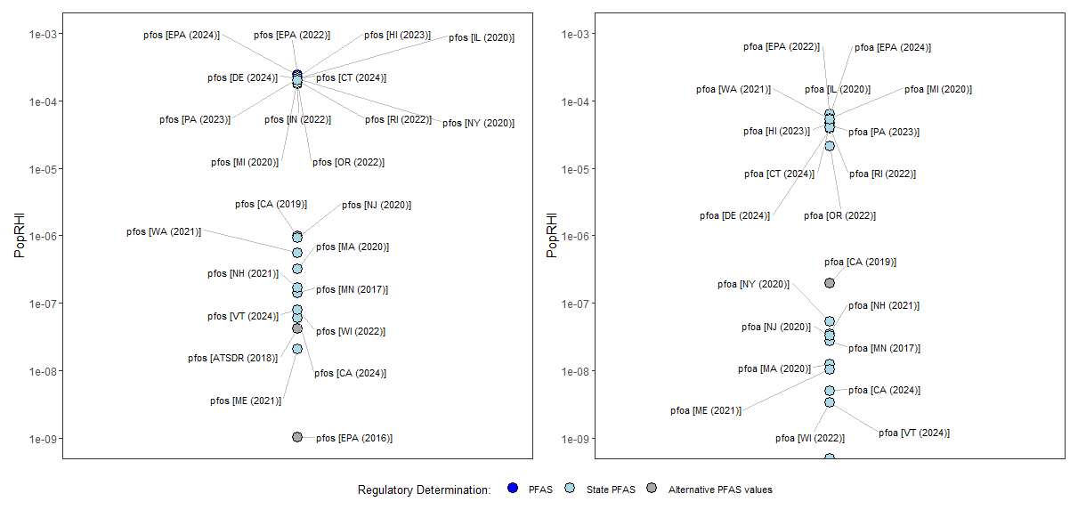

Figure 3. Population RHI for each regulatory determination (excluding NAs).

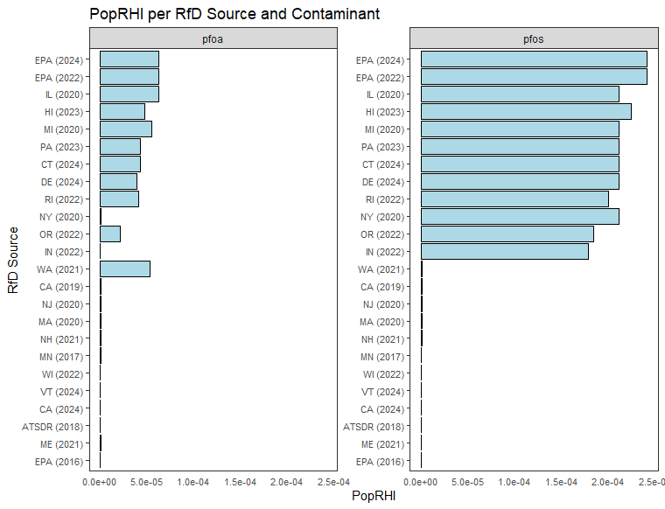
Figure 4. Population exposure by RfD Source for each PFOS and PFOA regulation (excluding NAs).

